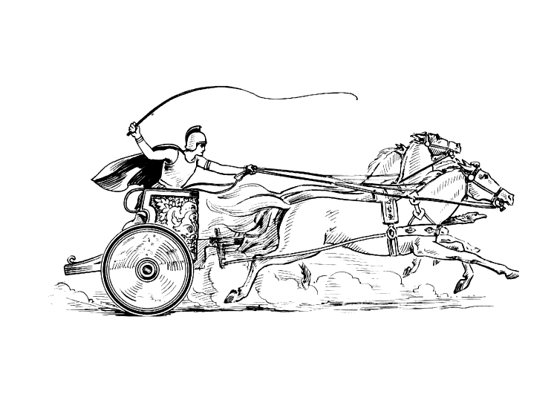 Manduessedum - Mancetter Village (Place of War Chariots)
Mancetter Parish Council
Serving the People of Mancetter and Ridge Lane

PARISH COUNCIL MEETING
OF THE PARISH OF MANCETTER

Minutes of the Parish Council Meeting of the Parish of Mancetter,
held on Tuesday 24th January 2023 at the Schoolroom
of St Peter’s Church Mancetter,
commencing at 7pm.

Present:
Chairman Mr T Hopkins.

Parish Councillors Mr H Blackburn, Mrs G Forknall, Mrs S Healy, Mr P Mann, Mrs N Wallis.

County Councillor Mrs M Bell.

Borough Councillor Mr A Clews.

Parish Clerk Mrs E Higgins.
Assistant Clerk Finance Mrs K Meads.

County Highways Rebecca Alcock, Reece Berry and Jeff Morris.

Item 1 - Welcome and Apologies

Mr T Hopkins welcomed everyone to the meeting at 7pm.

Apologies were received from Parish Councillor Sheila Dore due to illness. These apologies were accepted.

Borough Councillor Denise Clews was attending a meeting of the Licencing Committee, and PCSO Emily
Jenkins was on operational duty.

Item 2 – Recording of the meeting.

There was no recording of the meeting.

Item 3 – Notice of Interest.

Two councillors declared non-pecuniary interests in the following agenda items:

Trevor Hopkins 9b
Glynis Forknall 9b

Item 4 – Public Question Time.

There were no members of the public in attendance. The clerk had received an emailed request from a parishioner, concerning the Travellers site under the iron bridge on the border between Hartshill and Mancetter.

A copy of the letter was passed to Margaret Bell and Tony Clews as the County and Borough Councillors for Mancetter Parish. They will inform the parish council of the response to these questions.

Item 5 – Presentation by Jeff Morris from County Highways.

Jeff Morris is the Client Services Manager for County Highways and gave councillors an overview of the areas covered, and the roles and responsibilities of the County Highways Team.

He introduced Rebecca Alcock, the Client Team Leader for North Warwickshire, and Reece Berry who has become the new Locality Officer. Reece is the person who will be the main point of contact for 15 parishes within North Warwickshire for getting things done at a local level.

countyhighways@highways.co.uk should be used to report issues and concerns.

highwaysconsultation@warwickshire.gov.uk for matters relating to planning.

There was a useful exchange of information concerning outstanding issues; where the local knowledge of parish councillors was considered in the context of Highway contracts, legal requirements and resources.

Rebecca will email Elane Higgins the parish clerk with a summary of action points following on from the meeting.

Item 6– Update from Police, County and Borough Councillors.

Police

A brief report of statistics had been submitted to councillors, recording 24 separate incidents within Mancetter Parish between the 1st and 24th January 2023.

Councillor Forknall suggested obtaining more information on the locations, particularly as the parish council and County Highways are monitoring traffic issues.

County Council

The majority of issues had been covered within the discussion with County Highways. Graham Stanley had forwarded an update, and Scott Tompkins will be looking to attend the next meeting to discuss the Highways Community Action Fund and further options. Information on Levelling up and work on the Mill Lane foot bridge is recorded below under those subject headings.

Borough Council

Tony Clews fed back that the remaining Borough Councillor funding for our area will be used towards 50% of the cost of a zipwire to be installed at Mancetter Recreation Ground.

The rest has been contributed to the installation costs of CCTV to monitor anti-social behaviour occurring around the churchyard at St Peter’s.

Item 7 – Minutes of the last meeting.

The draft minutes from the 29th November 2022 were proposed by Harry Blackburn seconded by Peter Mann and therefore formally signed by the chairman as a true record of proceedings.

Item 8 – Matters arising from the previous minutes / Issues not covered in any other agenda points.

- Update on Cost-of-Living Briefing 10th January 2023

A comprehensive report had been forwarded to councillors prior to the meeting by Sue Healy, who attended the briefing as the parish council representative. It was agreed to have an ongoing agenda item relating to the cost-of-living issues facing our communities; drawing inspiration from the million people who already heat their homes off grid.

The Clerk will continue to signpost people towards help and resources available through the parish noticeboards, website and Facebook pages.

Councillor Healy is writing articles on the importance of being on the priority register with energy suppliers and purchasing heating oil collectively for domestic and commercial customers.

- Levelling up Pilot Scheme

Sue Healy and Karen Meads from Mancetter Parish Council are awaiting a meeting date to be set for the working group to commence.

It was agreed that education should form part of the initial focus.

Trevor Hopkins highlighted that as a rural as well as urban parish, the lack of school places and transport links, meant that children were being sent to separate schools from their neighbours and unable to build positive relationships.

Offering access to technology with support, as well as ensuring that people are aware of what is available is a good first step. This is not a new issue, and has affected successive generations of local children and their families.

- Atherstone Surgery Patient Participation Group

The group will meet every two months and offer suggestions and possible solutions to issues fed back by members of the public. Some improvements are awaiting grant funding.

A machine to take blood pressure readings has been installed within the surgery to help with the large amounts of people needing checks. Information is added to your medical notes and reception is alerted if there is a significant risk.

The next meeting will be on 13th February 2023.

- Water Colour of Coventry Canal near Mancetter

Following numerous concerns reported by residents over the colour of the water in the canal and the presence of a white residue, the parish council contacted the pollution control officer at the Borough Council.

The Environment Agency conducted a series of water quality tests and concluded that both issues related to the presence of natural occurring algae and its decomposition.

This information was shared through our communication channels and parishioners updated.

- Safety Options for Mill Lane Foot Bridge.

A Mancetter resident has once again reported some broken slats and the slippery surface of the foot bridge across the River Anker at the bottom of Mill Lane. Following a number of conversations with the Rights of Way Officer at Warwickshire County Council, it has been agreed to add non slip strips as each broken board is replaced.

- Re-organisation of North Warwickshire Area Committee

Richard Habgood has become the chair of the North Warwickshire Area Committee and Councillor Hopkins remains as Vice chair.

There is no subscription fee for the coming year, and all councils are invited to join this separately constituted group which operates independently from WALC.

Meetings are held in the Committee Room at the Borough Council and the next one is scheduled for 1st March 2023 at 7.30pm.

- Unsuccessful bids for Green Shoots Funding

The bids submitted by the Parish Council and Mancetter Memorial Hall were not successful within this round of funding. Feedback has been requested.

Item 9 – Finance

- Two councillors signed the financial paperwork since the last meeting in accordance with Standing Orders and the Bank Mandate.

- It was proposed by Mrs S Healy, seconded by Councillor Mann and approved unanimously, to authorise the Chairman Mr Hopkins to collect the Allotment Rents for the forthcoming year.

He will write a cheque to the council for the total amount; to negate the percentage charge for banking cash, particularly as the nearest counter service is now Market Bosworth in Leicestershire.

- Amendments to the draft budget and reserves were noted and agreed by all councillors.
- The final budget for 2023 2024 was then approved unanimously.

- The Parish Council discussed options for setting the precept for the forthcoming financial year.

It was proposed by Harry Blackburn, seconded by Nicky Wallis and unanimously approved:

To minimise the financial pressure on parishioners, it was agreed that in total an increase of £1,000 be applied, which equates to 2.09% on a band D property.

This is a rise of 99p per year.

Item 10- Planning Matters and New Applications since the previous meeting.

- Update on Approved, Rejected and Pending Applications and Appeals.

Councillors noted that the application for Canal Cottage was now pending further information being submitted. The refusal for holiday chalets on the site at Delamere in Purley Chase Lane was acknowledged, along with the permitted development for the installation of new electronic communication equipment at Leek Wootton Farm and within Ridge Lane linked to the 5G Network.

The decision of the Planning Inspectorate to approve the unauthorised development at the Kirby Glebe Travellers Site has prompted questions to be asked by parishioners. This information has been passed to the Borough and County Councillors for the parish. Anti – social behaviour will continue to be monitored, and residents are encouraged to report any concerns to the police and request a crime number.

- To discuss any new applications received

Comments will be submitted in relation to development at Whitehall Farm on Atherstone Road Hartshill.

Item 11– Cemetery and Maintenance around the Parish.

- Update on the consecration of future burial, cremation and scattering areas.

The Rev Linda Mudd has been liaising with the Coventry Diocese in relation to procedure and potential costings. This will be discussed at a future meeting.

- Repair of Parish Noticeboard in Mancetter Village

The Parish Council Noticeboard on the corner of Manor Road by the Post Office has reached a point where replacement will be necessary. The Clerk was asked to look into costings for a new board made from recycled plastic that will last for many years. A budget of up to £1,000 was set to cover purchase, delivery and installation costs.

- Planting of additional spring bulbs around the parish.

Approximately 600 spring bulbs have been planted in various locations around the villages of Mancetter and Ridge Lane to provide a wonderful floral display.

- Additional tree planting to mark the coronation/ replace any damaged jubilee trees

It was agreed by all councillors to mark out a crown with the cypher of King Charles III on the village green in Mancetter and on the grass verge in Ridge Lane using yellow flowers such as primulas.

In the Spring, the council will have a better idea as to how many of the Platinum Jubilee trees survived the extreme weather conditions shortly after they were planted.

- To consider an application for a new bench in the cemetery.

Councillors approved an application for a memorial Bench within the cemetery subject to the conditions laid out within the parish council bench policy.

Item 12 - Date of next meeting:

Parish Council Meeting Tuesday 28th March 2023 7pm in the Schoolroom, St Peter’s Church Mancetter.
As there was no further business the meeting closed at 9.25pm
Manduessedum - Mancetter Village
(Place of War Chariots)
Mancetter Parish Council
Serving the People of Mancetter and Ridge Lane

